ATA 26 August 21
West
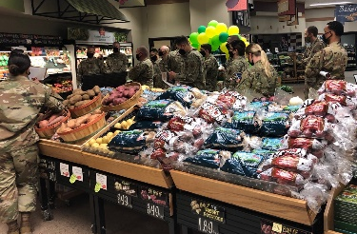
The Grand Forks Air Force Base Commissary, North Dakota, hosted the base dietician for a tour with airmen to explain the importance of healthy eating and choosing healthy alternatives while shopping at the commissary, August 24. (Photo by Donna Sharief, store director)

East
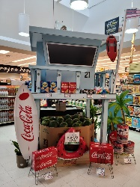
The Picatinny Arsenal Commissary, New Jersey, hosted this Summer Beach mass display created by Gwen Osborn, July 19. The display drew customers and made it easy to purchase all their summer fun items.

Central
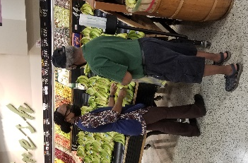
Melissa Walker, store worker at the Maxwell Air Force Base Commissary, Alabama, discusses the difference between Stage 2 and Stage 3 bananas with George Mosley, commissary customer, August 19.

Europe
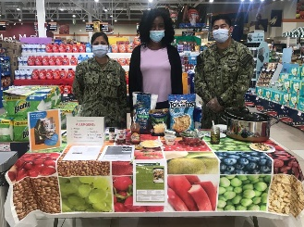
The Rota Commissary, Spain, hosted a culinary kitchen display, featuring chicken chili nachos, August 13.

Pacific
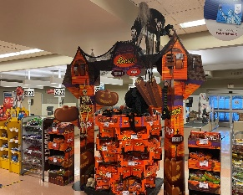

The Joint Base Lewis-McChord Commissary, Washington, created this eye-catching 2021 Halloween Display to scare up some additional customers, August 24. (Photo by Paula Lewis, zone manager)

